Demo UX Action Design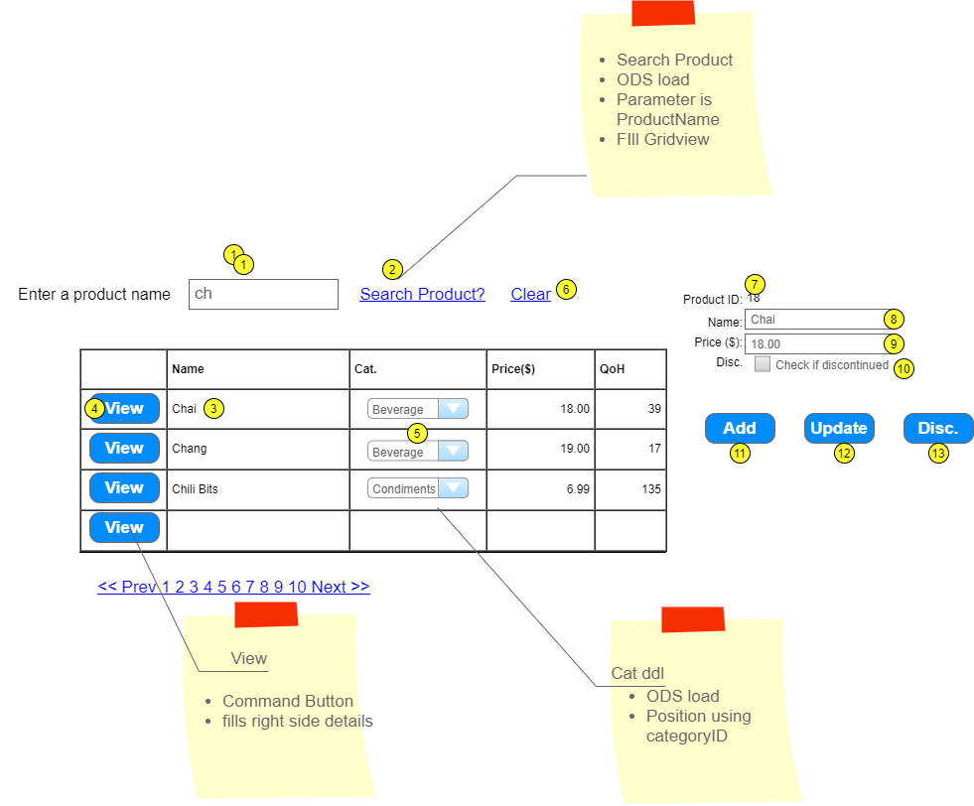

|  |  |  |  |  |  |
| --- | --- | --- | --- | --- | --- |
|  | Controls | Load/Usage | CRUD | Validation | Event Actions/notes |
| 1 | ProductArg | -/2 | R | presence |  |
| 2 | SearchProduct | 1/3 | R |  | Fires ODS for Gridview fill  **List<Product> Product_FindByPartialName(string)**  <EmptyDataTemplate> |
| 3 | ProductList | 3/4 | R |  | hidden field on roe for argumet id  Categry is ddl/ODS, customize, paging |
| 4 | Select Command button | -/7--10 | R |  | Collect idden field  **Product Product_FindByID(int)**  Fill product details |
| 5 |  |  |  |  |  |
| 6 |  |  |  |  |  |
| 7 |  |  |  |  |  |
| 8 | ProductName | 4/11,12 | CU | presence |  |
| 9 |  |  |  |  |  |
| 10 |  |  |  |  |  |
| 11 | Add | -/8-10 | C |  | Collection input values  Load an instance of Product  **Int Product_Add(product)**  Return new poduct id  Refresh ID (7) |
| 12 | Update | -/7-10 | U |  | Collection input values  Load an instance of Product  **Int Product_Upday(product)**  Return rows affected  Appropriate message |
| 13 |  |  |  |  |  |